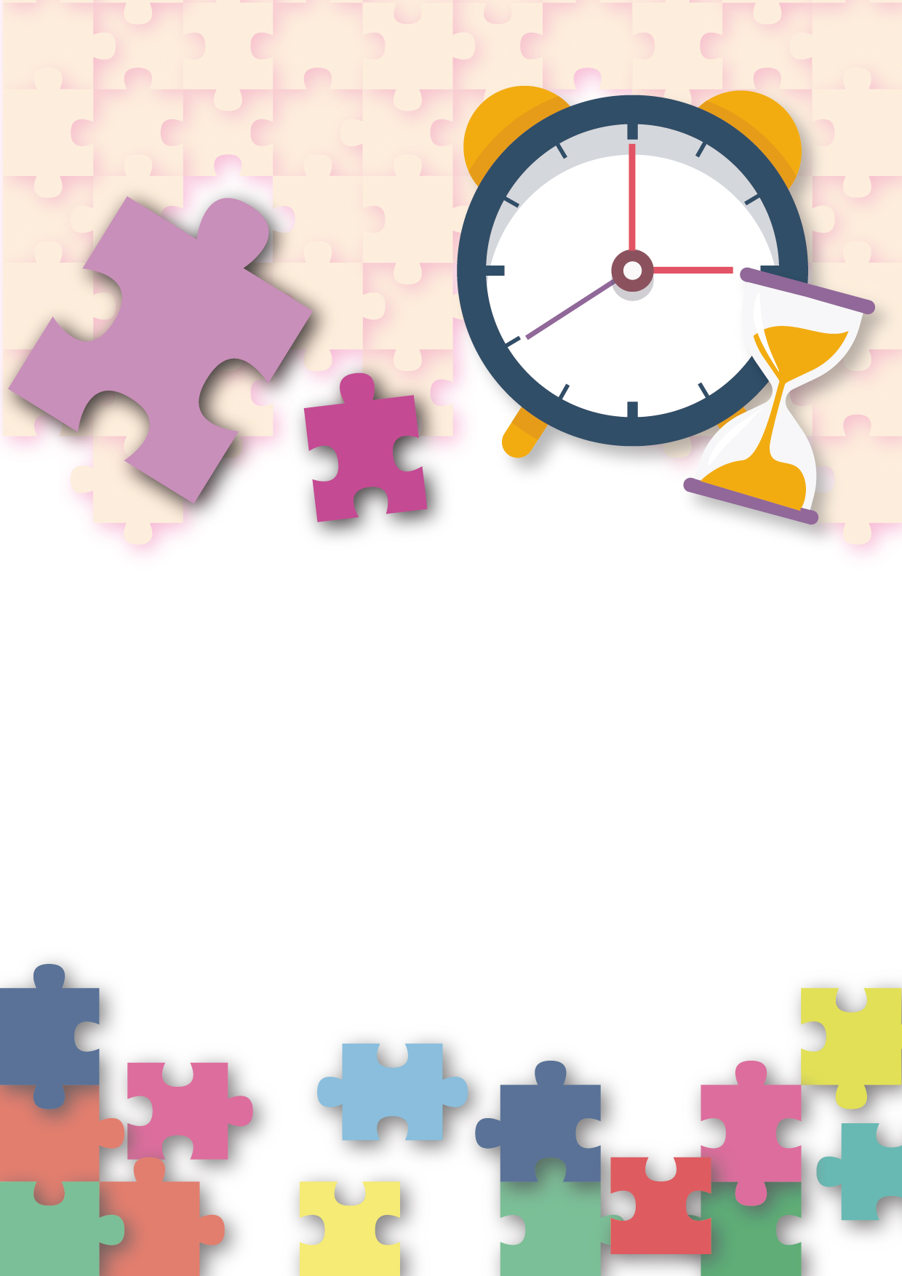
Citizenship, Economics and Society
(Secondary 1-3)
Support Resources
Secondary 1

Module 1.1
Self-understanding and Life Skills
Part 3:
Time Management
Personal, Social and Humanities Education Section
Curriculum Development Institute
Education Bureau

Introduction

- The “Citizenship, Economics and Society (Secondary1-3) Support Resources” covers the essential learning contents of Strands 1, 5 and 6 in the Personal, Social and Humanities Education Key Learning Area. It is designed to support the implementation of the Citizenship, Economics and Society curriculum.
- The support resources provide diversified learning activities to help students acquire knowledge and understand concepts, develop skills and nurture positive values and attitudes. In addition, they offer teaching guidelines and suggestions on learning and teaching activities for teachers’ reference. Further, they provide reading materials to enhance students’ interest in reading.
- “Module 1.1 Self-understanding and Life Skills Part 3: Time Management” for Secondary 1 was developed by the Personal, Social and Humanities Education Section, Curriculum Development Institute of the Education Bureau.

Module 1.1 Self-understanding and Life Skills
Part 3：Time Management

Contents

 | Pages
Teaching Design
Lesson 1 and Lesson 2: Time management strategies | 4
Learning and Teaching Activities
Worksheet 1: The importance of time management | 7
Worksheet 2: My time management strategies | 9
Worksheet 3: Effective time management strategies | 11
Worksheet 4: Personal reflection: My time management | 14
Joyful Reading
Wise Quotes | 15
References | 17

Teaching Design:
Topic: | Time Management
Duration: | 2 lessons
Learning Objectives: | - To know the importance of time management  - To master effective time management strategies
Lesson 1 and Lesson 2 (Time management strategies)
Pre-lesson Preparation: | Students finish the following before class:  - Finish “Activity: Problems caused by ‘time’” in Worksheet 1;  - Finish “Activity 1: Time management quiz” and “Activity 2: My time management discovery” (1) and (2) in Worksheet 2.
 |  | Suggested lesson time
Enquiry Process: | - Set: The teacher makes connection between these lessons and previous lessons so as to deepen students’ learning of life skills and set the stage for discussing the importance of time management. | 5 minutes
 | - Discussion and debriefing:  - Group discussion and presentation: Students work in groups of 4. With regard to “Activity: Problems caused by ‘time’” in Worksheet 1, students discuss the problems of the four characters in the use of time and the resulting impacts and then report to the whole class.  - Pair work: Students work in pairs to share the problems of their own and their friends in the use of time and the resulting impacts.  - Teacher debriefing: The teacher first invites a few students to share their personal experience, followed by a debriefing to help students understand the importance of time management. | 15 minutes
 | - Interactive teaching:  - Activity introduction: The teacher briefly introduces the purposes of “Activity 1: Time management quiz” and “Activity 2: My time management”* in Worksheet 2, which are to help students develop preliminary understanding of effective time management strategies by tasks of classifying different time management behaviours  *With the use of electronic applications (e.g., Kahoot!), students shall be able to share with the class their responses to the Quiz, which will enable them to learn each other’s situations in time management. After that, there should be a class discussion.  - Group discussion and presentation: With regard to “Activity 1” and “Activity 2” (1) and (2) in Worksheet 2, which have been completed before class, students work in groups to discuss their performances in different time management strategies and then report to the whole class.  - Peer learning: Students move on to “Activity 2” (3) and learn time management strategies from their peers. After that, the teacher invites a few students to share the strategies that they have learned from their peers.  - Teacher debriefing: The teacher summarises the main points of the discussion and tells students that they and their peers will explore time management strategies in the next part of the lesson. | 20 minutes
 | - Direct instruction:  - The teacher explains the requirements of “Activity 1: Learn effective time management” in Worksheet 3 and the importance of extracting key points from texts. And then, using “setting goals” as an example, the teacher demonstrates how to extract key points.  - The teacher emphasises to the students that they need to make sure that all their peers understand the contents and they reach a consensus on the titles and the key points. If there are different opinions among the students, the whole group should read and discuss again to reach a consensus. | 5 minutes
 | - Peer Learning*：Students work in groups of 4. Students in each group read two of the strategies in “Activity 1: Learn effective time management” in Worksheet 3 and finish the activity. Students add titles to the strategies that they have read and find out key points.  *The teacher facilitates the progress of the activity by reminding students to carry out different tasks at different stages. | 10 minutes
 | - Interactive teaching: The teacher invites students to report on the results of their discussion. During the process, the teacher helps students clarify, strengthen and deepen their learning through engaging their peers in asking questions and giving feedback. | 15 minutes
 | - Teacher debriefing:  - The teacher concludes what students have learned in Lesson 1 and Lesson 2 and reiterates the key learning points.  - The teacher encourages students to understand their needs, the routines of their daily life and the patterns of their behaviours, and to apply effective time management strategies that they have learned to improve their work efficiency and quality of life.  - The teacher encourages students to make use of the technique of “extracting key points” in preparing summaries or notes so that their learning effectiveness can be improved. | 5 minutes
 | - Conclusion: The teacher concludes the lesson and asks students to finish “Personal reflection: My time management” in Worksheet 4 according to what they have learned from class and their personal experience. | 5 minutes  (The teacher shall explain the requirements for homework.)
Extended Learning Activity: | Students read Appendix 1: “Joyful Reading: Wise Quotes” after class to learn and reflect on the messages of the wise quotes.
Learning and Teaching Resources: | Worksheets 1-4; Appendix 1

Module 1.1 Self-understanding and Life Skills
The teacher can ask students to finish Activity 1 and Activity 2 in Worksheet 1 before class.
Part 3: Time management
(Lessons 1 and 2)
Learning and Teaching Materials

In the last few lessons, we discussed the life skill of emotion management and how to deal with stress and anxiety as well as face failure and frustration. In fact, time management is also an important life skill. If we do not manage time properly, time may bring us stress, anxiety and other effects. On the contrary, good time management can help us get twice the result with half the effort and live a more fulfilling and meaningful life. Therefore, it is important to learn how to manage time well.

Worksheet 1: The importance of time management
Activity: Problems caused by “time”
- What problems do the following characters have in their use of time? What impact do these problems bring to them? Complete the table on the next page according to the contents of the dialogue boxes and the words in the dashed line box.
My life is very busy. After school, I have to participate in various activities, chat with my classmates in the evening, and then check out comments and some interesting information in social media groups. By the time I do my homework, it is already very late. After finishing my homework in a hurry, I haven't slept for a few hours, and I have to drag my tired body to school again!

I can’t take it anymore!
I am afraid of doing math homework. Therefore, I often put it off until late at night when I have no other choice. But then the people who can help me are all already asleep. It makes me feel helpless, so I dislike the subject even more and my grade gets even worse.
I am always busy with this and that, and forget this and that. Although I have worked very hard, in the end, what I needed to do was not completed, nor did I do what I wanted to do. I can never seem to keep up with the speed of time slipping away.

I feel very anxious and stressed, and depressed. I feel like a slave to time!
I just want everything to be perfect, but often because of lack of time, I can only finish the work carelessly after the deadline.

Since I often cannot finish the work before the deadline, my classmates are getting less and less willing to work with me on projects!

Siu Wai
Siu Ling
Siu Ip
Siu Kit

The teacher can ask more able students to answer by themselves without providing them with words in the dashed line box.
Excessive demands on own performance Lack of detailed planning

Procrastination Too many activities scheduled

 | Problems in the use of time  Note: Complete the following by selecting appropriate words from the dashed line box. | The impacts  （Suggested answers）
- Siu Wai | Lack of detailed planning | Bring anxiety and pressure to oneself
- Siu Ling | Excessive demands on own performance | Worsen relationship with classmates
- Siu Kit | Having too many social engagements | Affect physical health
- Siu Ip | Putting things off | Lead to poor grade

- In addition to the problems mentioned in Question 1 above, what other problems related to the use of time have you or your friends encountered? Put down your answer in the box below.

Time management is very important to us. If we do not have good time management and allow ourselves to be overwhelmed by excessive demands and become physically and mentally exhausted, this may bring us stress and anxiety, and adversely affect our health, relationships with other people and academic performance.

On the contrary, effective time management can help us reduce the stress and anxiety caused by lack of time, keep our lives organized, do things more efficiently, and lead a healthier and fulfilling life.

Worksheet 2: My time management strategies
Activity 1: Time management quiz
The following quiz can help you better understand your time management strategies. Please answer the following items honestly. If a statement can reflect your general situation, please put a tick (“”) in the space on the right; if a statement does not reflect your general situation, please put a cross (“”) in the space on the right.

Statements | ／
- I remind myself when to do something with a work list.
- I use some effective ways to relieve stress, such as doing sports or watching movies. I also ensure that I have enough time for rest and entertainment.
- I set realistic goals based on my existing time, resources and abilities.
- I will deal with important and urgent things first, rather than doing easy things first.
- I don't like putting things off and will start the tasks that need to be done right away.
- I set specific and clear goals.
- When I don't have time, I say "no" to other people's requests.
- I keep my workplace neat and clean so that I can concentrate on my work.
- I set up a reminder device on my phone to let me know when and what to do.
- I work seriously but will not be fault-picking or strive for perfection excessively.
- I break down difficult tasks into smaller, easier ones and complete them step by step.
- I will not delay the work on purpose because of my preferences.
- If my plan does not work out, I will make adjustment in order to attain the goal.
- I will not let other people or tasks interrupt my work.
- I arrange priority of my tasks according to their urgency and importance.

Quiz result: The more ticks (“”) you have, the better your time management strategies are. If you have more crosses (“”), it means that you have more room for improvement in time management.

Activity 2: My time management discovery
The teacher can use electronic applications (e.g. “Kahoot!”) to show the responses of the whole class.
Six time management strategies are shown in the diagram below. According to your responses in Activity 1, complete the following tasks to understand your performance in different strategies.
- In the space of each time management strategy, fill in the number of the relevant quiz statement;
- Add a circle to the number of a statement with a “”, such as ; add a triangle to the number of a statement with a “”, such as ;
- Exchange your worksheet with a classmate next to you to find out what time management strategies he or she has but you do not have, and then ask the classmate how he or she manages time using the strategies.

Worksheet 3: Effective time management strategies
How to find the key point?
- According to the requirements of the question, find out the sentences related to the title, and select and judge the more important key parts or points.
- Ignore supplementary elaborations, examples or repetitive parts.
Activity 1: Learn effective time management
1. Read “Learn effective time management strategies and be the master of time” and complete the following tasks.
(1) Refer to “Activity 2” in Worksheet 2 and add titles to each of the strategies; and
(2) Find out and underline the key points of each strategy that can achieve effective time management.

Learn effective time management strategies and
be the master of time
Set goals
- ____________________________________
Examples of Goals
- Complete data processing and analysis for project learning.
- Obtain 5 marks higher in math exam than in math test.
- Break classmate’s record of doing 18 sit-ups consecutively.
- Save money in a year to buy a bicycle.

2
1
Time is precious. To ensure that time is effectively used and cultivated a habit of self-discipline and diligence, the goals we set must be specific, clear and realistic. Therefore, when setting goals, we have to review our current situation such as time, resources, and capabilities, assess the importance of the goals to us, and decide what actions to take to achieve the goals. Don't forget to reward yourself after reaching your goals, so you can keep your enthusiasm for hard work.
3
Plan work and allocate time
- ___________________________________
1
After setting the goals, plan the required actions, the time required for each action, and the timeline for completing each action. When faced with difficult work, we should break down the work into several smaller parts, and then complete these parts step by step. Sometimes the progress of work may not be very smooth, so we should prepare contingency plans or other ways to achieve our goals.
Example of Plan
Goal | Actions required | Time required | Deadline
Complete data processing and analysis for project learning | - Input data into computer  - Make bar charts to present the data  - Analyse the data according to the enquiry questions, and display the results in point form | 20 mins  10 mins  60 mins | Before Thursday

4
3
2
In terms of allocating time, don't fill every time slot to allow time to cope with unanticipated situations. In addition, we must work seriously, but we should not pick faults, demand perfection in everything, and ignore the scale of work involved and time allocated beforehand.
5

Importance and urgency
- Which of the following activities do you think is important and which is urgent?
- Watch your favourite game about to be broadcast on TV.
- Go to the market to buy food for mother to cook after she comes home from work.
- How would you prioritize the above activities?
1
- ___________________________________
Set priorities
Priorities should be set according to the importance and urgency of the matters. We should give high priority to tasks which are both important and urgent because some tasks are urgent but not necessarily important.
3
2
In addition, when setting work priorities, don’t just give high priority to easy tasks. This can prevent us from over-focusing on easy tasks while not devoting enough time to important tasks.
You can refer to the following figure to determine the priority of tasks.
1 represents the highest priority tasks, while 4 represents the lowest priority tasks.
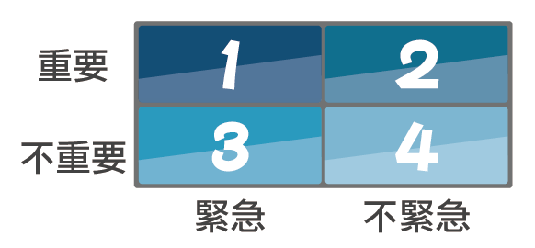
Important

Not important
Urgent Not urgent

Create to-do list and set up reminder system
- ___________________________________
建立待辦清單及設定提醒機制
Create the to-do list by setting up a reminder system, we can see what we need to do at a glance, so that we will not easily forget our work and are able to focus on important things. Moreover, deleting an item from the list after completing a task will be an encouragement and a motivation for continuous efforts.
To-do list
- Pay class club fee.
- Borrow notes from Tsz Yan during recess.
- Renew books online.
- Remind mom to pay home internet service fee.
- …
1
Tasks on the to-do list should be classified into important or unimportant and urgent or non-urgent according to priority. The list must be reviewed and updated regularly, with completed tasks deleted and new tasks added. Important or urgent items are highlighted with symbols.
2
In addition, we should also set up a reminder system, such as using a diary to note down important information, so as not to miss any important deadlines when we are busy.
3

- ____________________________________
Reasons for delaying work
- Lack of interest
- Avoid difficult tasks
- Excessive worry
- No urgency
- ……

Do not put things off
Putting things off is not a solution for problems. Leaving unfinished tasks at the last minute will only make situations worse. Regardless of the reason for the delay, facing a problem with a firm will and a positive attitude is the correct way to deal with it. The right way to deal with it is to be diligent and willing to work. For example, when we want to avoid a difficult task, we should build confidence and willpower to overcome it. In fact, difficulties and fears are often not as difficult to handle and overcome as one thought. Moreover, when a difficult task can finally be completed before the deadline, we will have stronger confidence and motivation to meet the next challenge.
2
1
Therefore, we should act decisively when we do things, and in many cases when we are determined to take action, it is also the best time to do things.
Improve work efficiency

- ____________________________________
The most basic element of effective time management is to improve work efficiency. With improved work efficiency, there will be more time to do what we need to do and what we want to do. Developing good work habits can greatly improve work efficiency. Here are some examples.
1
- Keep the work space tidy and clean.
- Do not allow other people or tasks to interrupt the work, and keep yourself focused.
- Say “no” to other people’s requests when you are busy or when the deadline is approaching.
- Make good use of the gap time, such as using the waiting time in the queue to plan things, update the to-do list, etc.
- Arrange work according to your own condition, for example, arranging the most important work at a time when you are in the best condition and have the highest efficiency.
2
In addition, maintaining good physical and mental health and balance between work and rest are the most important conditions for improving work efficiency. Therefore, we should develop healthy lifestyles, such as having a balanced diet, regular exercise, adequate sleep, adequate rest and recreation time; maintaining a positive outlook on life and a happy and cheerful mood; and adopting appropriate methods to relieve stress and anxiety.

Worksheet 4: Personal reflection: My time management
The teacher can ask less able students to propose strategies to improve the problems of one of the characters in “Activity 1” in Worksheet 1 and explain how the situation of the character will be improved with the proposed strategies. After that, they shall be invited to analyse the problems of themselves and give suggestions and explanations.
Refer to “Activity 1” in Worksheet 1, Worksheet 3 and personal experience to complete the following tasks:
- Describe a problem in your use of time and the impact of this problem on you.
- Choose at least one time management strategy to improve the problem and provide an explanation.

My problem with the use of time:

Impact on me:
Time management strategies to improve problems:

How to improve:
Draw your portrait

In these two lessons, you have learned the importance of time management and effective time management strategies. Hope you can know better how you use your time and how you can adjust your daily routines and practices using effective time management strategies. At the same time, remember to persevere in practice, so as not to waste precious time and live a more abundant life.
Draw your portrait
Appendix 1
Joyful Reading
Wise Quotes
Here are some enlightening wise quotes about time. Let’s take a look at them!
 | Nevertheless, few people treasure their time as much as their life. | LIANG Shih-chiu
 | Time is like the water in a sponge and you will always get it if you squeeze it. | Lu Xun
 | Young ages will never come again, as well as the mornings that have passed. Study hard when you can, because time waits for no man. | TAO Yuanming
 | It is easy to learn for the youngsters and hard to make achievement for the elders. Not a moment should be wasted. | Zhu Xi
 | Time is live. Time is speed. Time is power. | GUO Moruo
 | Don’t idle away your time when you are young, otherwise you will feel sad and regretful when you are old. | YUE Fei
 | The wee hours with cockcrow are the best study hours for a young fellow. But if you a black-haired lad who is so slack, when old, it’ll be too late to feel sorrow. | YAN Zhenqing
 | Time flies. | Anonymous
 | A sky is fixable, an ocean, reclaimable, while time, unrecallable. | ZENG Guofan
 | A young idler, an old beggar. | OUYANG Xiu
 | Lost time is never found again. | Benjamin Franklin
 | Yesterday is gone. Tomorrow has not yet come. We have only today. Let us begin. | Mother Teresa
 | A man who dares to waste one hour of life has not discovered the value of life. | Charles Darwin
 | Better three hours too soon than one minute too late. | William Shakespeare
 | My advice is, never do tomorrow what you can do today. Procrastination is the thief of time. | Charles Dickens

Source:
http://mingyanjiaju.org/juzi/mingrenmingyan/2012/0229/279.html
http://www.tw117.com/mingyan-ren/朱熹/
http://www.chinesewords.org/wisdom/show-252.html
http://www.chinesewords.org/wisdom/show-1528.html
www.wiseoldsayings.com/time-quotes/
https://tw.18dao.net/名人名言/時間
https://www.goodreads.com/quotes/tag/time
https://tw.18dao.net/名人名言/（宋）歐陽修

Reflective Questions:
- Which wise quote about time listed above encourages you most? Why?
- Free answer
- Which wise quotes about time listed above remind you to make good use of time, be diligent and self-disciplined to live a life without regret?
- Young ages will never come again, as well as the mornings that have passed. Study hard when you can, because time waits for no man. TAO Yuanming
- It is easy to learn for the youngsters and hard to make achievement for the elders. Not a moment should be wasted. Zhu Xi
- Don’t idle away your time when you are young, otherwise you will feel sad and regretful when you are old. YUE Fei
- The wee hours with cockcrow are the best study hours for a young fellow. But if you a black-haired lad who is so slack, when old, it’ll be too late to feel sorrow. YAN Zhenqing
- A sky is fixable, an ocean, reclaimable, while time, unrecallable. ZENG Guofan
- A young idler, an old beggar. OUYANG Xiu
- My advice is, never do tomorrow what you can do today. Procrastination is the thief of time. Charles Dickens

- Try to create quotes that encourage others to make good use of time, be diligent and self-disciplined to live a life without regret.
Free answer

- Actually, we can also find a lot of wise quotes on the internet and in libraries, which are worthy of our study and reflection. Let’s find more and read more in our spare time!
References
Student Health Service, Department of Health (2014). Health Information: Learning Time Management. Retrieved from:
https://www.studenthealth.gov.hk/tc_chi/health/health_lea/health_lea_timemgt.html

The University of Kent (n.d.). How to Manage Your Time Effectively. Retrieved from: https://www.kent.ac.uk/careers/sk/time.htm

